Z532- Information Architecture for the Web: Solution Definition

Pallavi Murthy

[murthyp@indiana.edu](mailto:murthyp@indiana.edu)

The proposed website prototype will increase the website’s usability and attract more users. Users can be now provided with more up to date information and each user can do specific tasks as desired as opposed to the current existing website where users are left confused as all the users are brought into ne page and asked to navigate deep down to the desired web page which is cumbersome as well not what a user prefers in any website. With having a moving image on the home page with happening news/information piece provided by the people of IU Scholar Works, users can be more aware of current news the minute they enter the website. The video on the right side of the proposed wireframe page is evident to bring success for IU Scholar Works by having demo videos on How-to deposit scholarly works, How-to publish online journal, conference talks held by the Dean, Head librarian etc. and some useful information regarding IU Scholar Works deposition, creation of online article policies. The widgets on the right side of the page are the statistics collected over a period of time. Most popular article of the month can be fetched by using data analysis tools such as Google Analytics. The most frequently accessed article, total number of viewers etc. can be made visible to the users on the Homepage of the proposed website. The wireframe of the proposed website is structured and distributed equally throughout the website. The Home page button, research tab, journals tab as opposed to the current website is placed on top of the Homepage of the proposed website as a navigation tab and a drop down menu containing the sub web pages of each tab. The wireframes are numbered beginning from Home page for better understanding of the subpages and links. There are new additional features added in the proposed wireframe such as widgets to view the current statistics of articles and journals. The center of the Homepage will have rotating images of people in IUScholarWorks and any flash news happening in IUSW. This gives a pleasing visual and instant update about the happening event to IUSW users. The drop down menu helps users to have a look at the subpages with just having to keep the cursor on the tab.

**Snapshots of proposed website prototype**

IUSW Proposed HomePage

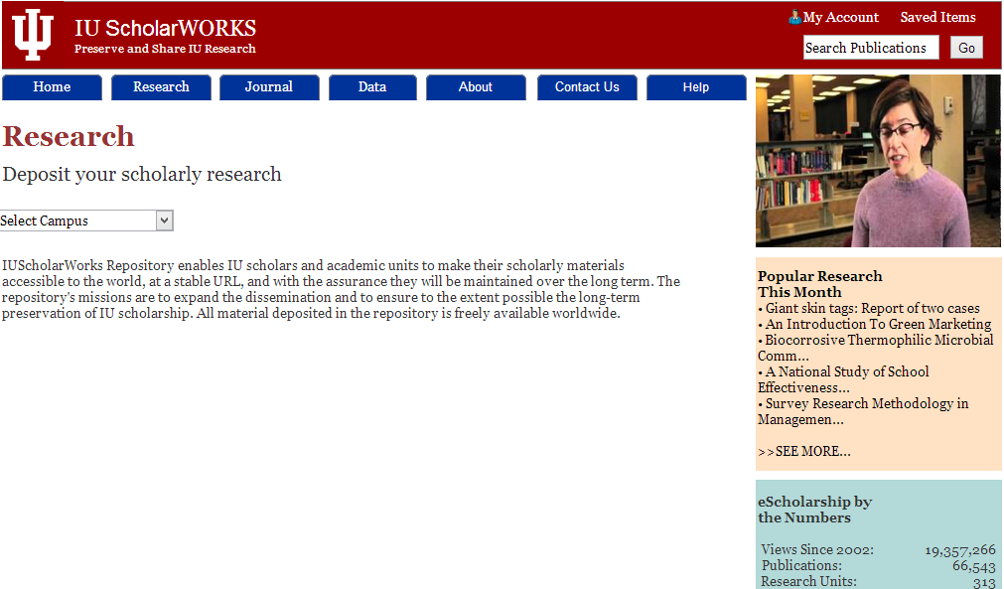

IUSW Research Page



IUSW Data Page

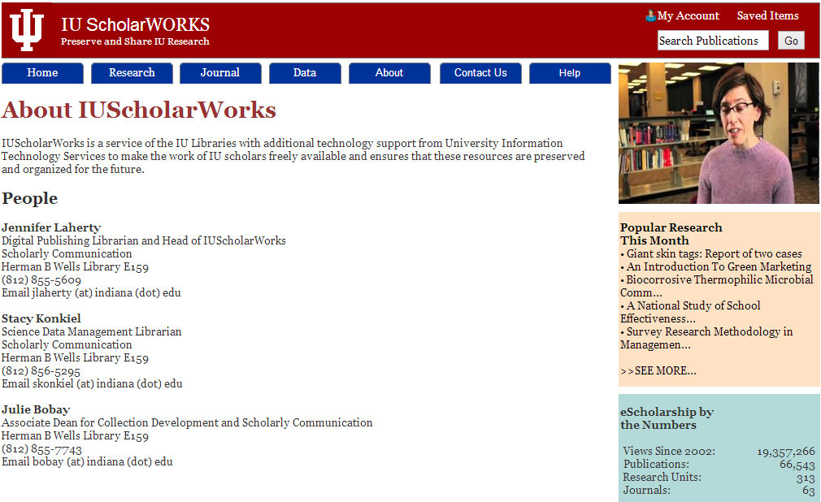

IUSW About page

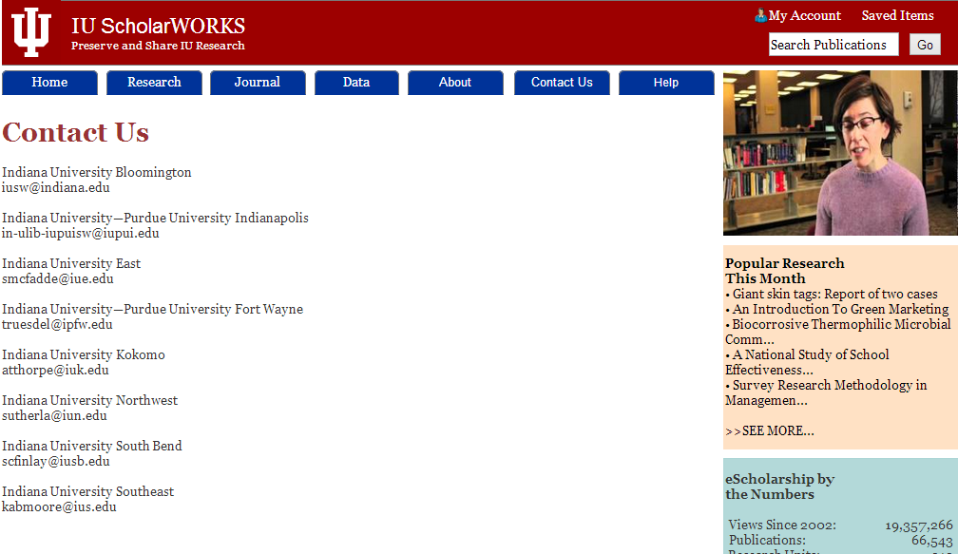

IUSW Contact Us Page

**Site-level diagram**

